

SPARK: Simple Play Adaptations to Reference for Kids

Spiky Tactile Cushion
Description: | Image:
A sensory seat cushion designed especially for sensory seekers! Spiky on one side and bumpy on the other, so kids can choose which type of tactile input they prefer.  Purchasing Information | 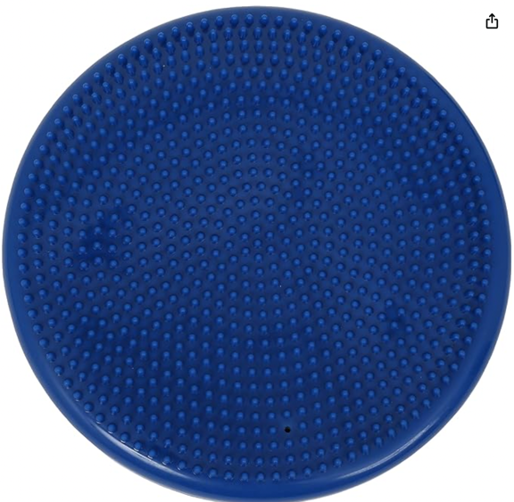

Who Might Benefit?
Those who…
• Need more opportunities to move while engaged in activities that typically require a maintained seated position.
• Have difficulty remaining focused during seated activities and may need a small amount of sensory input through movement.
• Need mild seating supports to maintain a more functional ready to work posture.
• Need mild balance challenges while seated to support better ready to work posture.

Why Use?
Provides an opportunity to…
• Experience a more “ready to work” sitting posture.
• Move while in their seat without the need to get up to move.
• Encourage self-regulation to improve focus on work and play activities.
• Stimulate sitting and standing balance for improved posture while engaged in other functional activities.
• Improve body awareness.
• Enhance sensory processing skills.
Instructions for Use: | Adaptation Ideas:
Environmental Considerations  - Use in any environment in the home, community, or school that requires sitting on a chair such as at a desk/table at school, at home at the dinner table, and in the community in a restaurant, or movie theater. It can also be used for sitting on the floor such as for circle time at school. It is easily transportable among environments.  Positioning  - Use on a chair or on the floor for a variety of seated positions including long, cross-legged, side, and bent knee long sitting.  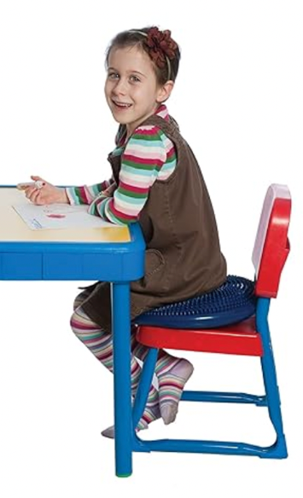  Alternate Positioning  - Use in standing, kneeling and half kneeling positions to engage the child in balance activities.  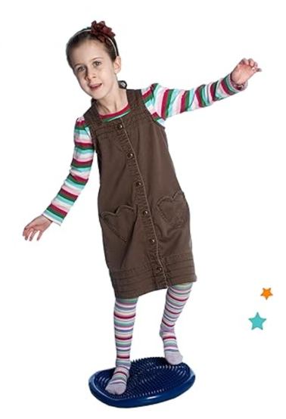  - While sitting the cushion can be used under the feet as a footrest to provide increased sensory input to the feet.  - The cushion can also be used as a backrest inside the chair back to enhance sensory input to the back and better position the child for the “ready to learn” sitting position.  Basic Play/Use  - Use in a chair to help the child engage more effectively in table top activities or other chair seated activities.  - Use on the floor to provide a visual boundary of the child’s sitting space while engaged in structured group activities such as circle time.  Extended Play/Use  - While seated on the cushion encourage the child to reach for objects in various locations (e.g. pick up colored objects on the floor and place on the table on corresponding color mat for color matching, sort items into a bucket placed to the left or right sides of the child).  - While seated on the cushion encourage the child to lift objects of various weights to increase sensory input (in the fall create a pumpkin patch with various size and weight pumpkins to pick up).  Play/Use with Others  - Child sits on the cushion while tossing a ball or bean bags to another child or engaging in a simple board game at the table with another child. | Optional Additional Materials/Supplies  - Dycem or cabinet shelf liner  Stabilize It  - Dycem may be used under the cushion to help stabilize it to the chair or floor if it slides around.  Contain It  - Use on a chair with arms to provide more trunk support to the child and to prevent the cushion from moving to the side.  Add Sensory Cues  - The cushion has two sides with different textures. One side has smooth spikes and the other has small bumps, both provide sensory input. Use with either side up depending on child’s preference.  Communication Supports  - Visual supports (non-transient cues) such as movement vocabulary cards (stand, sit, here, there, reach, throw, etc.) can be used to pair with verbal directions (transient cues) provided to the child to help them learn about the way things and people move in space.  - Social stories with themes related to staying seated, playing reaching and throwing games and be used to increase expectations of behavior during activities and game play.  Alternative Uses  - Use in an obstacle course to provide a balance challenging obstacle for children to step on and walk over.  - Use for gross motor standing balance activities such as the child standing on the disk and throws bean bags or balls into a container or engages in vertical activities such as drawing on paper hung on the wall. The challenge can be increased by offering items for reaching and placement at differing levels (up high, down low, to the right, and to the left, etc.)  DIY Alternatives  - Beach balls can be used to provide seated movement. The beach ball is minimally/moderately inflated for the needed amount of movement. This is not a good alternative for children who are using a cushion to assist with more appropriate position for work/play at a table. Additionally, beach balls are not as durable as the commercially available seat cushions.  *”Adaptations” adapted from: Haugen’s Modes for Adapting Toys based on materials from the "Let's Play" Project at the University of Buffalo.

Additional Considerations:
- This item contains small parts (plug for inflation air hole) and should not be used with children under 3 years old.
- The amount of air provided in the cushion can impact the challenge and amount of sensory feedback the child receives from the cushion. Be sure to try varied amounts of air to determine what works best for the child.

Resources:
- See Social Narratives from OCALI’s Autism Center Grab and Go Resource Gallery of Interventions.
- For further information, visit the Social Narratives Autism Internet Module.
- Like Social Stories, Power Cards teach and reinforce academic, behavioral, organizational, and social skills. Power Cards are visual supports that include an individual’s special interest. See Power Cards from OCALI’s Autism Center Grab and Go Resource Gallery of Interventions.
- Reminder Cue Cards from OCALI’s Autism Center Grab and Go Resource Gallery of Interventions help teach and remind individuals how to engage in positive behaviors. Reminder Cue Cards provide “what to do” suggestions when an individual is feeling anxious, stressed, or confused. They also support interactions with peers, and offer ways to self-regulate, and manage emotions.

Ohio Early Learning Standards:
- SE: Self-Regulation: Begins to manage emotions and reactions (2.a.)
- AL: Engagement and Persistence: Persists in completing a task with increasing concentration. (1.c.)

Words to Encourage Play/Use
Sit  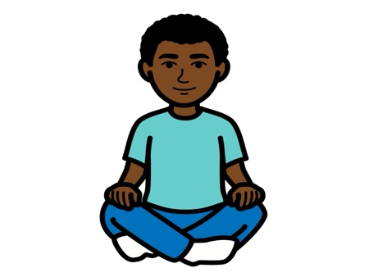 | Here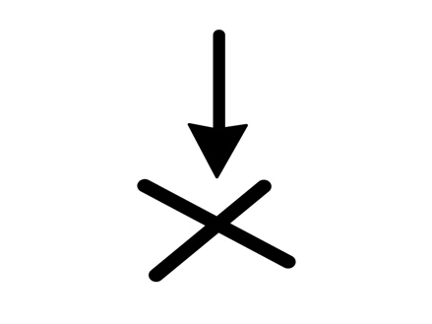 | Ready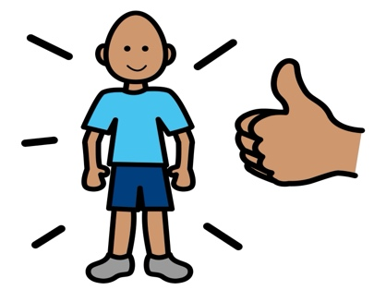
Move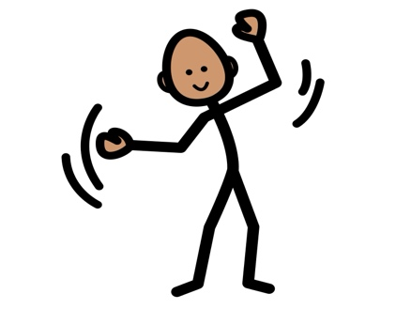 | Stand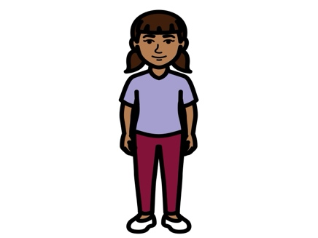 | Chair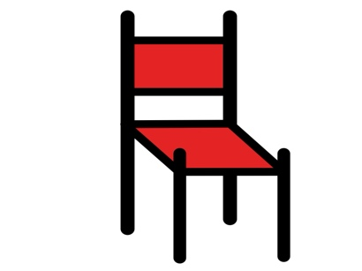
Touch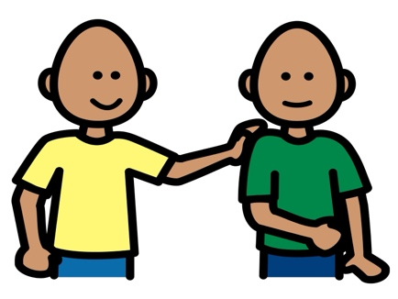 | On  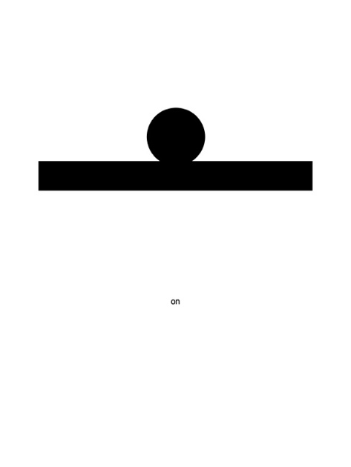 | Off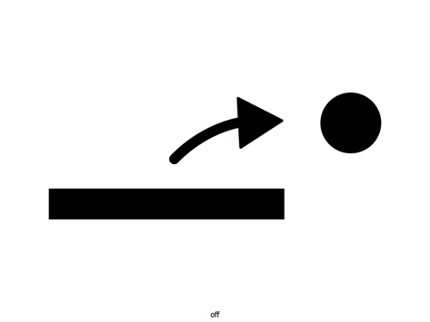
PCS is a trademark of Tobii Dynavox, LLC. All rights reserved. Used with permission.

